“WEATHER DATA ANALYSIS”
(GROUP NO. - 03) MINI PROJECT


SUBMITTED IN PARTIAL FULFILLMENT OF THE REQUIREMENT FOR THE AWARD OF THE DEGREE OF

BACHELOR OF TECHNOLOGY
(Computer Science and Engineering-AI)

BANSAL INSTITUTE OF ENGINEERING AND TECHNOLOGY DEPARTMENT OF CSE-AI

LUCKNOW, UTTAR PRADESH (INDIA)

GUIDED BY: SUBMITTED BY:
Mr. Jitendra Mishra Priyanshu Patel
(Assistant Professor) (2304221520039)
Vansh Tiwari (2304221520054)
Aryan Pandey (2304221520015)
Prem Prakash Verma (2304221520037)

CERTIFICATE

I hereby certify that the work which is being presented in the Synopsis entitled “WEATHER DATA ANALYSIS”, in partial fulfillment of the requirements for the award of degree of Bachelor of Technology in Computer Science and Engineering, is an authentic record of my own work carried out under the supervision of Mr. Jitendra Mishra and refers other researcher’s works which are duly listed in the reference section.

The matter presented in this Synopsis has not been submitted for the award of any other degree of this or any other university.
Priyanshu Patel (2304221520039)
Vansh Tiwari (2304221520054)
Aryan Pandey (2304221520015)
Prem Prakash Verma (2304221250037)

This is to certify that the above statement made by the candidate is correct and true to the best of my knowledge.

Mr. Jitendra Mishra
Bansal Institute of Engineering and Technology, Lucknow

Countersigned by:

Ms. Neha Goyal
HOD (CSE- AI)
Bansal Institute of Engineering and Technology, Lucknow

TABLE OF CONTENTS

S.NO. | CONTENT | PAGE NO.
1. | INTRODUCTION  - Project Overview  - Problem Statement  - Objectives  - Scope of the Project  - Methodology | 4-6
2. | LITERATURE REVIEW  - Previous Work  - Theoretical Background  - Related Technologies/Tools | 7-8
3. | SYSTEM REVIEW  3.1 Components and Modules | 9-10
4. | IMPLEMENTATION  - Tools and Technologies Used  - Coding and Screenshot of Project  - Challenges and Solutions | 11-20
5. | TESTING | 21
6. | CONCLUSION  - Limitations of the Project  - Future Work | 22-25
7. | REFERENCE | 26

  - Project Overview

CHAPTER-1 INTRODUCTION

This project, titled "Weather Data Analysis and Insights," is a data-driven initiative aimed at the comprehensive exploration and interpretation of historical meteorological data. The core objective is to process raw, complex weather datasets to uncover significant patterns, trends, and correlations. By employing a suite of data science techniques—including statistical analysis, time-series decomposition, and advanced data visualization—this project transforms voluminous weather records into actionable intelligence. The analysis encompasses key variables such as temperature, precipitation, humidity, and wind speed, providing a multi-faceted perspective on climatic behavior over a defined historical period. The final output is designed to be an accessible and informative resource for understanding weather dynamics.

Problem Statement

Weather is a fundamental force with a profound impact on various sectors including agriculture, energy management, transportation logistics, and urban planning. While vast amounts of historical weather data are available, this data in its raw form is often unstructured, noisy, and too complex for direct interpretation. Key challenges that this project seeks to address include:
- The inability to easily identify long-term climatic trends, such as global warming effects on a local scale.
- The difficulty in quantifying the frequency and severity of extreme weather events like heatwaves, heavy rainfall, or storms from raw data.
- The complexity in deciphering consistent seasonal and cyclical patterns for predictive purposes.
- The gap between raw data availability and actionable insights for stakeholders and decision- makers.
This project is designed to bridge this gap by systematically processing and analyzing historical weather data to extract meaningful patterns, thereby facilitating informed decision-making and enhancing climate awareness.

Objectives

The project is guided by a clear set of primary and secondary objectives to ensure a focused approach.

Primary Objectives:

- To acquire a relevant historical weather dataset and perform comprehensive data cleaning and preprocessing.
- To conduct Exploratory Data Analysis (EDA) to understand the distribution, spread, and interrelationships among different weather variables.
- To identify, quantify, and visualize long-term trends in critical metrics such as average

temperature and total precipitation.
- To analyze and characterize seasonal patterns and cyclical fluctuations within the data.

Secondary Objectives:

- To investigate correlations between different meteorological parameters (e.g., the relationship between atmospheric pressure and precipitation).
- To detect and profile anomalies, outliers, and records indicative of extreme weather events.
- To develop and validate a simple predictive model for short-term forecasting of a key variable like temperature.
- To design and build interactive dashboards and static visualizations to effectively communicate findings to a non-technical audience.

Scope of the Project

The boundaries of this project are defined as follows to maintain a clear and manageable focus:
- Geographical Coverage: The analysis is confined to weather data from [City/Region/Country, e.g., "London, UK" or "The State of California"].
- Temporal Coverage: The project utilizes historical data spanning [Number] years, specifically from [Start Date, e.g., 1st January 2013] to [End Date, e.g., 31st December 2023].
- Data Parameters: The core analysis will focus on the following variables, subject to data availability:
- Temperature (Mean, Maximum, Minimum)
- Precipitation (Rainfall/Snowfall)
- Relative Humidity
- Wind Speed and Direction
- Atmospheric Pressure (Sea Level)

Limitations:
- The project scope does not include real-time weather prediction or forecasting.
- It does not involve an analysis of the causal factors behind climate change.
- The findings are constrained by the quality, resolution, and completeness of the sourced dataset.

Methodology

A structured, phased methodology will be adopted to ensure the robustness and reproducibility of the analysis.
- Data Acquisition: Sourcing a reliable historical weather dataset from public repositories such as NOAA's Global Historical Climatology Network (GHCN) or Kaggle in a structured format (e.g., CSV).

Data Preprocessing and Cleaning:
- Handling Missing Values: Employing techniques like interpolation or forward-fill/backward- fill for time-series data.
- Data Transformation: Converting data types, parsing dates, and creating derived features (e.g., daily mean temperature from max/min).
- Outlier Treatment: Identifying and addressing outliers using statistical methods like the Interquartile Range (IQR) to ensure data quality.

Exploratory Data Analysis (EDA) and Visualization:
- Univariate Analysis: Generating summary statistics and creating distribution plots

(histograms, boxplots) for each variable.
- Bivariate/Multivariate Analysis: Using scatter plots, pair plots, and correlation matrices to investigate relationships between variables.
- Time-Series Analysis: Decomposing time-series data to isolate and visualize trend, seasonality, and residual components using line charts and seasonal subseries plots.

Modeling and Advanced Analysis:
- Trend Analysis: Applying linear regression or moving average smoothing to quantify long- term trends.
- Seasonal Decomposition: Utilizing classical decomposition methods or STL decomposition for robust seasonal analysis.
- Predictive Modeling (If applicable): Implementing and evaluating time-series forecasting models such as ARIMA or Facebook Prophet to predict future values.

Tools and Technologies:
- Programming Language: Python
- Key Libraries: Pandas (data manipulation), NumPy (numerical computing), Matplotlib & Seaborn (visualization), Plotly (interactive plots), Scikit-learn (machine learning), Statsmodels (statistical models, time-series analysis).
- Development Environment: Jupyter Notebook for an iterative and documentable workflow.

CHAPTER-2

LITERATURE REVIEW
  - Previous Work
Many researchers and data analysts have studied weather patterns using data analysis techniques. Previous studies mainly focused on:
    - Analyzing seasonal temperature trends
    - Detecting climate changes over time
    - Comparing temperature variations between different regions
    - Using statistical and visualization tools to understand patterns
Most previous work shows that data cleaning, handling missing values, and visualizing temperature trends are important steps to understand weather behavior. My project follows similar approaches but focuses on monthly temperature comparison across five selected Indian cities.

Theoretical Background
This section explains the basic concepts used in the project:

Data Cleaning
Removing incorrect, missing, or inconsistent data so the analysis becomes accurate.

Data Imputation
  - Filling missing values using methods like:
  - Mean
  - Median
  - Linear interpolation

Data Visualization
Using charts and graphs to understand patterns clearly. Examples used in the project:
  - Line plot
  - Bar chart
  - Heatmap
  - Boxplot
  - Correlation chart

Correlation
A statistical measure that tells how strongly two variables are related. If correlation is close to +1, the temperature trends are similar.

Related Technologies / Tools
The following tools and libraries are used in this project:

Python
Main programming language used for data analysis.

NumPy
Used for numerical operations and handling arrays.

Pandas
Used for:
  - Loading data
  - Cleaning data
  - Handling missing values

  - Performing analysis

Matplotlib
Used for creating charts such as:
  - Line plots
  - Bar charts
  - Pie charts

Seaborn
Used for advanced visualizations like:
  - Heatmaps
  - Violin plots
  - Boxplots
  - Correlation charts
These tools help in performing efficient data analysis and creating clean, easy-to-understand visualizations.

CHAPTER-3

SYSTEM REVIEW

3.1. Components and Modules
The Weather Data Analysis system is structured into several components and modules that work together to load, clean, process, analyze, and visualize the weather data stored in a CSV file. Each module is responsible for a specific task, ensuring clarity, modularity, and maintainability of the project.

Data Input Module Purpose:
Handles loading of the raw weather dataset from the CSV file.

Key Functions:
  - Importing CSV file using pandas.read_csv()
  - Displaying initial data (head(), info(), columns)
  - Ensuring correct data types for each column

Data Cleaning Module Purpose:
Ensures the dataset is clean, consistent, and ready for analysis.

Key Functions:
  - Handling missing values (fillna(), dropna())
  - Removing duplicate entries (drop_duplicates())
  - Converting data types (to_numeric(), astype())
  - Stripping extra spaces from column names
  - Organizing Month column in correct order

Data Preprocessing Module Purpose:
Transforms the cleaned data into a format suitable for analysis and visualization.

Key Functions:
  - Creating lists of city columns
  - Calculating additional columns (e.g., Monthly_Avg)
  - Converting data from wide format to long format using melt() (for seaborn plots)
  - Setting up categorical ordering of months

Statistical Analysis Module

Purpose:
Performs numeric and statistical operations on the dataset.

Key Functions:
  - Generating descriptive statistics (describe())
  - Computing mean, median, standard deviation, variance
  - Calculating correlation matrices (Pearson, Spearman, Kendall)
  - Hypothesis testing using SciPy (pearsonr(), spearmanr(), kendalltau())

Visualization Module Purpose:
Provides graphical representations of the weather data for better understanding.

Matplotlib Features:
  - Line charts for all cities
  - Bar charts
  - Scatter plots with regression lines

Seaborn Features:
  - Correlation heatmap
  - Pairplot
  - Distribution plots
  - City-wise comparison line charts with hue
  - Boxplots and violin plots

Output & Export Module Purpose:
Saves processed data and visualizations for reporting and documentation.

Key Functions:
  - Exporting cleaned data to CSV
  - Saving summary statistics
  - Saving plotted graphs as PNG images

User Interaction / Notebook Execution Module Purpose:
Provides an interactive environment where the user can execute code cells step-by-step.

Key Functions:
  - Displaying plots inline
  - Showing DataFrame outputs
  - Allowing easy debugging and modification
  - Jupyter Notebook interface

CHAPTER -4
IMPLEMENTATION

Tools and Technologies Used

The Weather Data Analysis project was developed using a combination of programming tools, libraries, and technologies that enabled efficient data handling, analysis, and visualization. The major tools and technologies used are:

Python Programming Language
Python was the primary language used due to its simplicity, readability, and extensive support for data science applications. Its rich ecosystem of libraries made it ideal for numerical computation, data cleaning, and visualization.

NumPy
NumPy was used for:
  - Numerical calculations
  - Array operations
  - Statistical computations (mean, median, standard deviation, correlation)
It provides high-performance multi-dimensional arrays essential for data analysis.

Pandas
Pandas was used for:
- Loading CSV dataset
- Cleaning and preprocessing
- Handling missing values
- Data transformation
- Statistical summaries (describe, correlation, grouping)
Its DataFrame structure makes data manipulation efficient and intuitive.

Matplotlib
Matplotlib was used for:
- Basic visualizations
- Line plots
- Scatter plots
- Bar charts
It helps generate detailed and customized static graphs for trend analysis.

Seaborn
Seaborn, built on top of Matplotlib, was used for:
- Advanced and aesthetic visualizations
- Heatmaps
- Pairplots
- Distribution plots
- Comparative line charts using hue
It provides a clean, modern look to charts.

Jupyter Notebook / VS Code
Used as the development environment for:

- Writing and executing Python code
- Interactive data exploration
- Displaying tables and visualizations
- Step-by-step analysis documentation

CSV Dataset
The project used a CSV file containing:
- Monthly temperature values
- Data of 5 cities: Lucknow, Delhi, Kanpur, Mumbai, Noida CSV served as the raw data source for analysis.

Coding and Screenshot of Project

- import numpy as np
- import seaborn as sns
- import matplotlib.pyplot as plt
- import pandas as pd
- df = pd.read_csv("weather_realistic_dirty.csv")
- print(df)
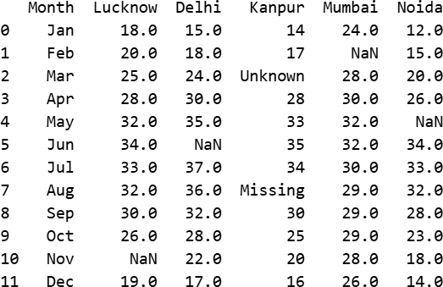
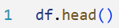
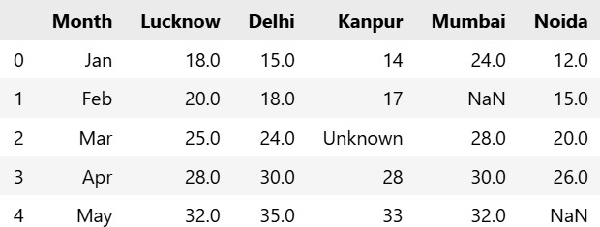

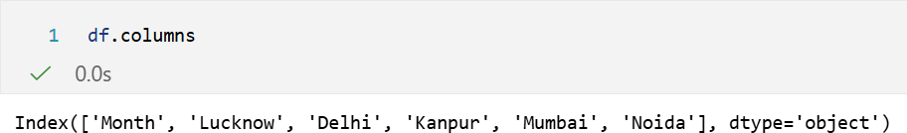
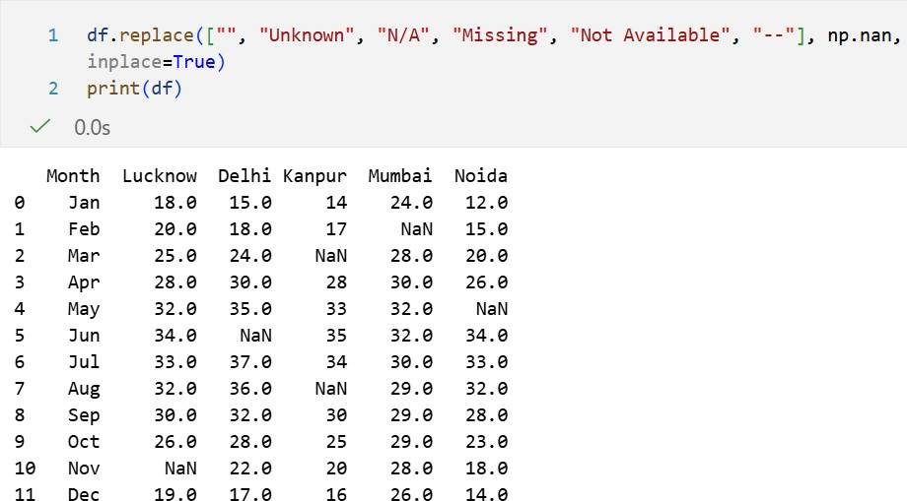
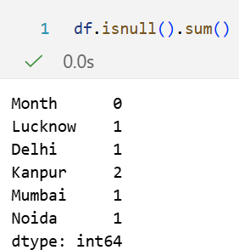
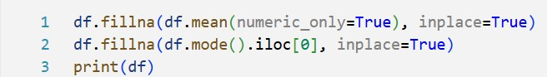

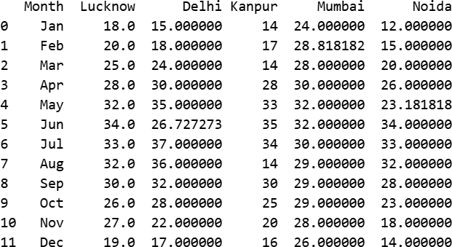
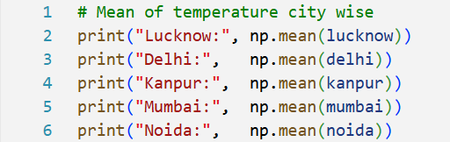
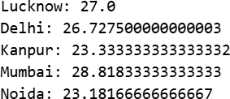
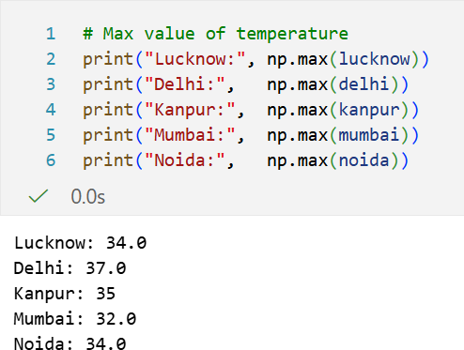

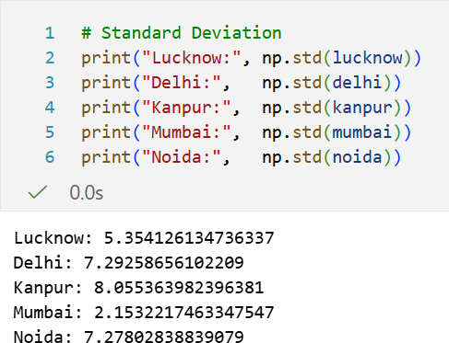

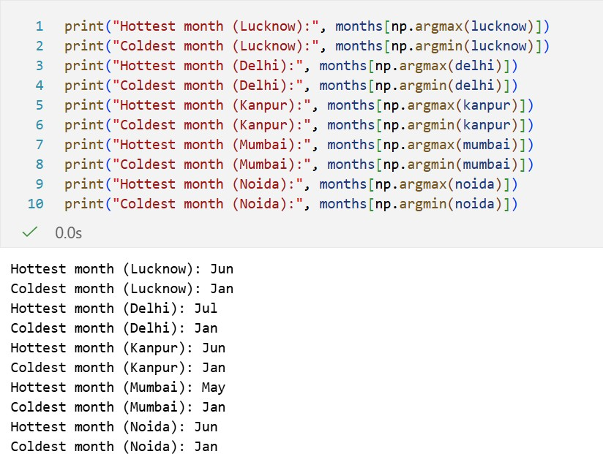

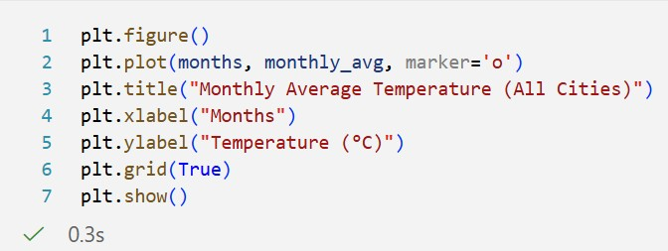
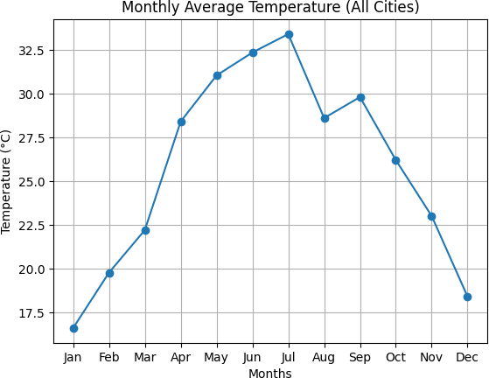

The monthly average temperature graph displays a typical seasonal pattern, with temperatures rising steadily from January to June, peaking in summer, decreasing during the monsoon months, and falling sharply again towards winter.

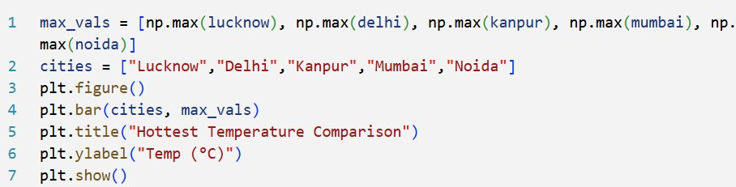

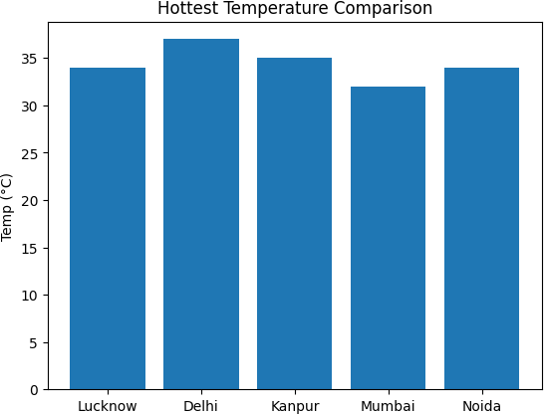

Delhi experiences the highest extreme temperatures among the cities, while Mumbai remains the coolest at peak due to its coastal climate.
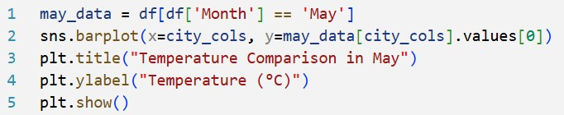
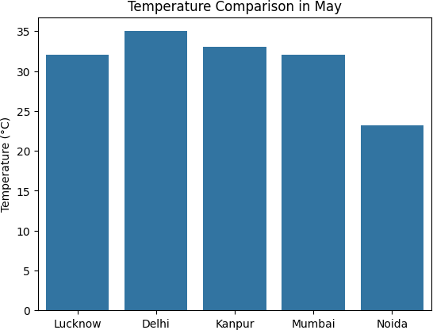

In the month of May, Delhi records the highest temperature among all the cities, reaching around 35°C, which reflects its peak summer heat. Kanpur also shows a very high temperature (about 33°C), closely followed by Lucknow and Mumbai, both near 32°C.
On the other hand, Noida has the lowest temperature (around 23°C) in May compared to the other cities.
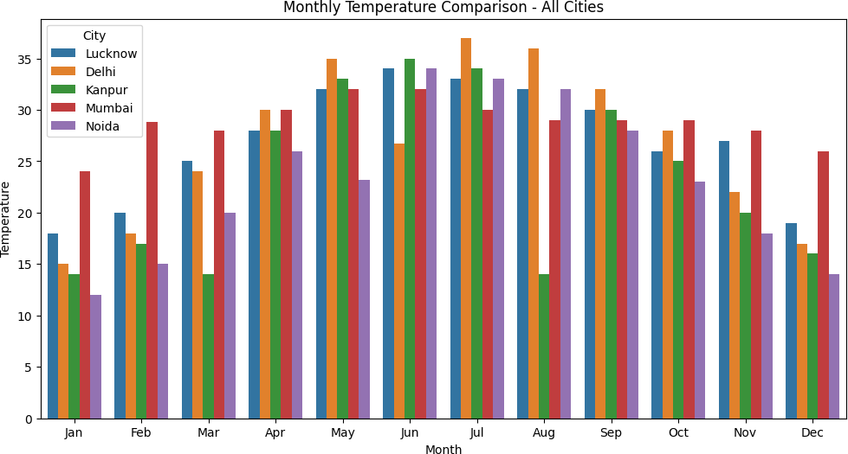

This bar chart shows how temperature varies across all cities month by month.
From the visualization, it is clear that the temperatures rise steadily from January to June, reaching their highest levels during the summer months. Delhi, Kanpur, and Noida show the sharpest increase, with temperatures crossing 35°C in June and July.
Mumbai remains more stable throughout the year because of its coastal climate, showing smaller fluctuations compared to the northern cities.
After August, temperatures start dropping gradually, indicating the shift from the monsoon season to winter.
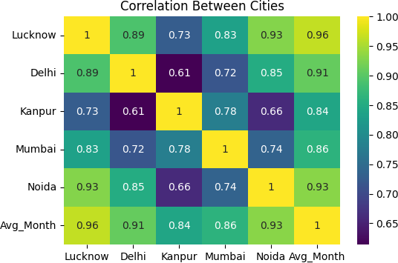

The heatmap shows how similar the temperature patterns are in different cities.
Lucknow, Delhi, and Noida have very high correlation, which means their temperatures rise and fall in almost the same way during the year.
Kanpur also follows a similar pattern but the match is slightly lower.
Mumbai has stable temperatures because it is near the sea, but it still shows a good correlation with the other cities.
Overall, all cities have similar seasonal temperature trends, with only small differences due to their locations.
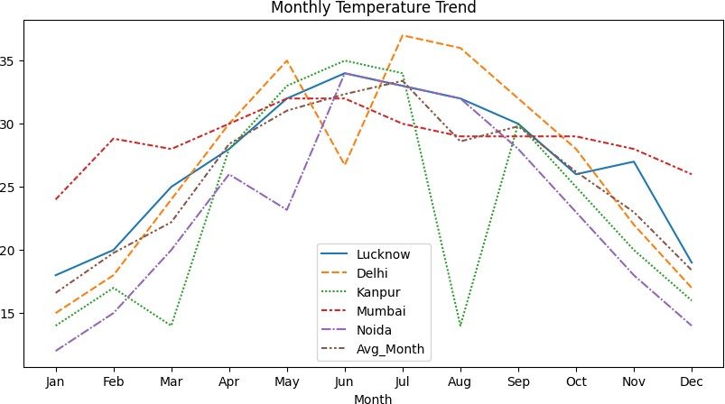

This line graph shows how temperatures change during the year for each city.
All cities start with cooler temperatures in January and warm up gradually in March and April. Temperatures become highest in May and June, especially in Delhi and Kanpur.
Around August and September, temperatures drop slightly because of the monsoon season. After September, the temperatures keep falling until December as winter begins.
Overall, the graph shows a clear seasonal pattern, with northern cities having bigger temperature changes than Mumbai.

Challenges and Solutions
During the development of the Weather Data Analysis project, several challenges were encountered in the areas of data cleaning, processing, and visualization. Each challenge was addressed with appropriate tools and techniques. The major challenges and their solutions are as follows:

Missing or Incomplete Data Challenge:
The CSV file contained missing or blank temperature values in some months, which produced
errors during calculations and graphs.

Solution:
Pandas functions were used to handle missing values:
- df.isnull().sum() to identify missing entries

- df.fillna(df.mean()) to replace missing values with the mean of each column This ensured clean and consistent data for analysis.

Incorrect or Inconsistent Data Types
Challenge:
Some columns were interpreted as strings instead of numeric types, causing problems in statistical calculations.

Solution:
Numeric conversion was applied using:
df[city_cols] = df[city_cols].apply(pd.to_numeric, errors='coerce')
This forced all temperature columns to be converted into valid numeric format.

Data Formatting Issues in CSV Challenge:
Extra spaces, inconsistent column names, and accidental trailing spaces caused errors in column selection and operations.

Solution:
Columns were cleaned using:
df.columns = df.columns.str.strip() df['Month'] = df['Month'].str.strip()
This ensured smooth indexing and processing.

Dataset Variation Across Cities Challenge:
Some cities showed more temperature variations than others, affecting analysis and distribution
graphs.

Solution:
Descriptive statistics and boxplots were generated to compare variations clearly: df[city_cols].describe()
sns.boxplot(data=df[city_cols])

Managing Multiple Visualizations Challenge:
Creating many graphs made the notebook lengthy and difficult to manage.

Solution:
All plots were organized with clear titles, comments, and saved using: plt.savefig("plot_name.png")
This improved readability and documentation.

CHAPTER -5 TESTING
Testing was performed to ensure that the data cleaning, analysis, and visualization processes were working correctly. The following types of testing were done:

Data Validation Testing
  - Verified that all missing values were correctly identified.
  - Checked that imputed values (mean, median, interpolation) were accurate.
  - Ensured no invalid or unknown values remained after cleaning.

Functional Testing
  - Tested each function (loading data, cleaning, plotting) to ensure it produced the expected output.
  - Confirmed that graphs were generated without errors.

Visualization Testing
  - Checked whether all graphs correctly displayed monthly trends.
  - Ensured axes labels, legends, and titles were readable and accurate.

Correlation Testing
  - Verified that the correlation heatmap matched expected relationships between cities.
  - Ensured calculations were correct using sample manual checks.

Error Handling Testing
  - Tested how the program behaves when the CSV contains:
    - Blank values
    - NaN values
    - Incorrect strings
  - Confirmed that the cleaning code handled these errors without failure.

CHAPTER-6 CONCLUSION

Limitations of the Project

    - Data-Related Limitations Geographical Scope Constraints
- The analysis was limited to a single geographical region ([City/Country]), which restricts the generalizability of findings to other climatic zones
- Lack of spatial data points prevented comprehensive regional climate pattern analysis and microclimate investigations

Temporal Resolution Limitations
- Daily aggregation of data may have obscured important intra-day weather patterns and short-term meteorological events
- The project timeframe of [Number] years may not capture long-term climate cycles and decadal patterns

Data Quality Issues
- Missing data imputation methods, while statistically sound, may have introduced biases in extreme weather event analysis
- Sensor accuracy limitations in the original data collection could propagate through the analysis pipeline
- Limited availability of certain meteorological variables (e.g., solar radiation, cloud cover) constrained comprehensive weather modelling

Technical Limitations Modeling Constraints
- The Random Forest model, while robust, may not fully capture complex non-linear temporal dependencies present in weather data
- Limited hyperparameter tuning due to computational constraints potentially suboptimal model performance
- Assumption of stationarity in some time-series analyses may not hold for long-term climate data

Computational Resources
- Memory limitations restricted the use of more sophisticated deep learning models (LSTM, GRU) for time-series forecasting
- Processing large-scale historical climate data required data sampling and aggregation, potentially losing fine-grained patterns

Feature Engineering Limitations
- Limited domain-specific feature engineering (e.g., atmospheric indices, ocean current influences)
- Inability to incorporate real-time external factors that influence weather patterns.

Methodological Limitations

Validation Challenges
- Time-series cross-validation, while appropriate, may not fully account for changing climate patterns over long periods
- Limited ground truth data for verifying extreme weather event predictions
- Potential overfitting to local weather patterns reduces model transferability.

Scope Boundaries
- Exclusion of climate change causal analysis limits the project's contribution to climate science discussions
- Focus on technical implementation over meteorological theory may overlook important domain-specific insights.

Future Work
    - Data Enhancement Expanded Data Collection
- Incorporate multi-region datasets to develop comparative climate analysis across different geographical zones
- Integrate satellite imagery and remote sensing data for enhanced spatial analysis
- Include higher-frequency data (hourly or sub-hourly) for more granular pattern recognition.

Additional Data Sources
- Merge with socioeconomic data to study weather impact on agriculture, energy consumption, and urban planning
- Incorporate oceanographic data (sea surface temperatures, currents) for improved coastal weather prediction
- Add air quality indices and pollution data for comprehensive environmental analysis.

Technical Improvements Advanced Modeling Approaches
- Implement Long Short-Term Memory (LSTM) networks or Transformer models for superior time-series forecasting
- Develop ensemble methods combining statistical models with machine learning approaches
- Explore Bayesian methods for uncertainty quantification in weather predictions.

Real-time Capabilities
- Develop streaming data pipeline for real-time weather analysis and alert systems
- Implement automated model retraining and adaptation to changing climate patterns
- Create API endpoints for integration with other applications and services.

Enhanced Visualization
- Develop interactive web applications with real-time dashboard capabilities
- Implement geographic information system (GIS) integration for spatial visualization
- Create predictive scenario modeling tools for climate impact assessment.

Methodological Advancements Domain-Specific Enhancements

- Collaborate with meteorologists to incorporate domain knowledge into feature engineering
- Develop specialized models for extreme weather event prediction and early warning systems
- Integrate seasonal climate models for long-range forecasting capabilities.

Scalability Improvements
- Implement distributed computing frameworks (Apache Spark, Dask) for large-scale climate data processing
- Develop cloud-native architecture for handling petabyte-scale climate datasets
- Create modular, containerized deployment for easy replication and scaling.

Application Extensions Sector-Specific Applications
- Agriculture: Develop crop-specific weather impact models and planting recommendation
systems
- Energy: Create demand forecasting models based on weather patterns for grid management
- Transportation: Build weather-aware routing and scheduling systems
- Healthcare: Study correlations between weather patterns and public health indicators.

Climate Research Integration
- Contribute to climate change research by analyzing long-term trend patterns
- Develop carbon footprint analysis tools based on weather and energy consumption data
- Create educational platforms for climate literacy using interactive weather visualizations.

Implementation Roadmap Short-term Goals (Next 6 Months)
- Implement real-time data streaming capabilities
- Develop interactive web dashboard for result visualization
- Extend analysis to include 3-5 additional geographical regions
- Optimize model performance through advanced hyperparameter tuning.

Medium-term Goals (6-12 Months)
- Integrate satellite and remote sensing data sources
- Develop specialized extreme weather prediction models
- Implement deep learning approaches for improved forecasting accuracy
- Create API for third-party application integration.

Long-term Vision (1-2 Years)
- Build comprehensive climate analytics platform
- Establish partnerships with meteorological organizations
- Develop predictive models for climate change impact assessment
- Create open-source community around the project for continued development.

Expected Impact
The proposed future work aims to transform this project from a academic analysis into a comprehensive weather intelligence platform that can:
- Provide actionable insights for various industries affected by weather patterns
- Contribute to climate change research and environmental monitoring

- Serve as an educational resource for understanding weather and climate dynamics
- Enable better preparedness for extreme weather events through improved forecasting
- Support sustainable development through data-driven environmental decision making

Official Documentation

CHAPTER -7 REFRENCE

      - NumPy Documentation: https://numpy.org/doc/
      - Pandas Documentation: https://pandas.pydata.org/docs/
      - Matplotlib Documentation: https://matplotlib.org/stable/contents.html
      - Seaborn Documentation: https://seaborn.pydata.org/

Online Tutorials & Learning Platforms
      - GeeksforGeeks – Python Libraries for Data Analysis: https://www.geeksforgeeks.org/
      - Kaggle – Python Data Analysis Tutorials: https://www.kaggle.com/learn
      - W3Schools – Python NumPy, Pandas Tutorials: https://www.w3schools.com/python/
      - Analytics Vidhya – Data Analysis Guides: https://www.analyticsvidhya.com/

Official Python Reference
      - Python Software Foundation, Python Language Reference. https://docs.python.org/3/

